Pinger Output for 127.0.0.1

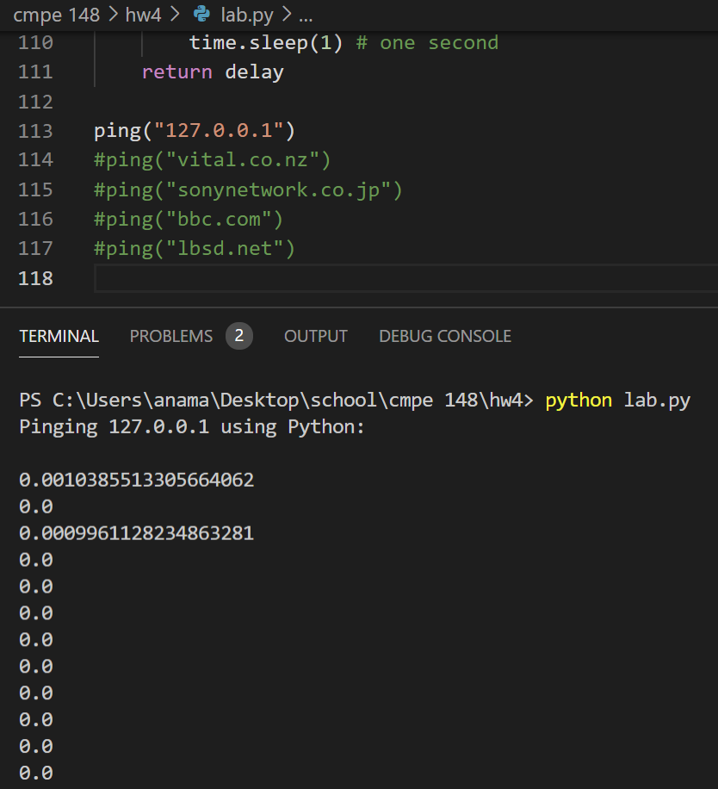

Pinger Output for vital.co.nz

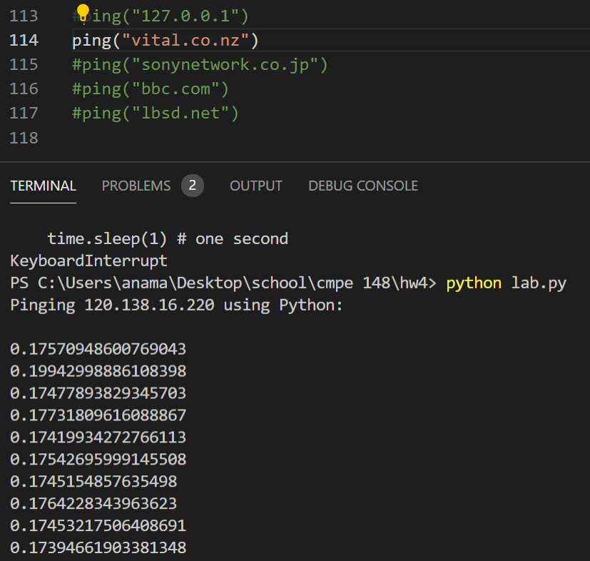

Pinger Output for sonynetwork.co.jp

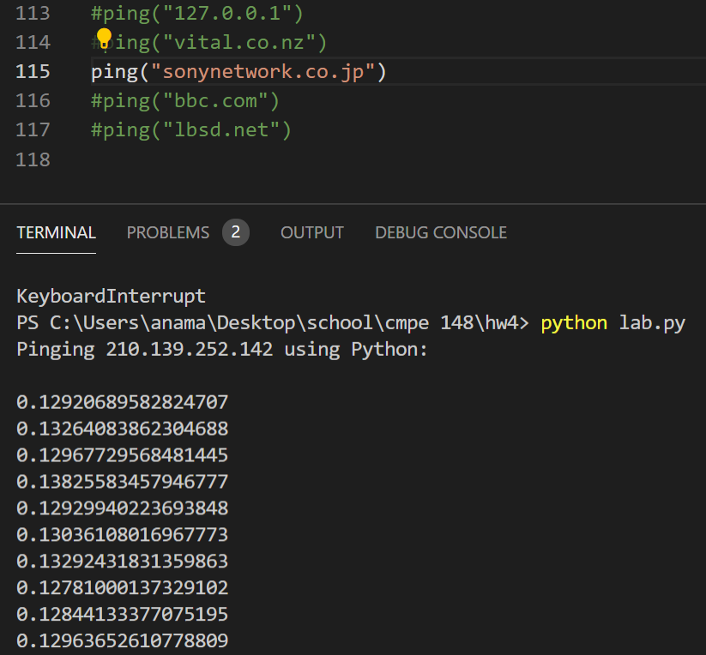

Pinger Output for bbc.com

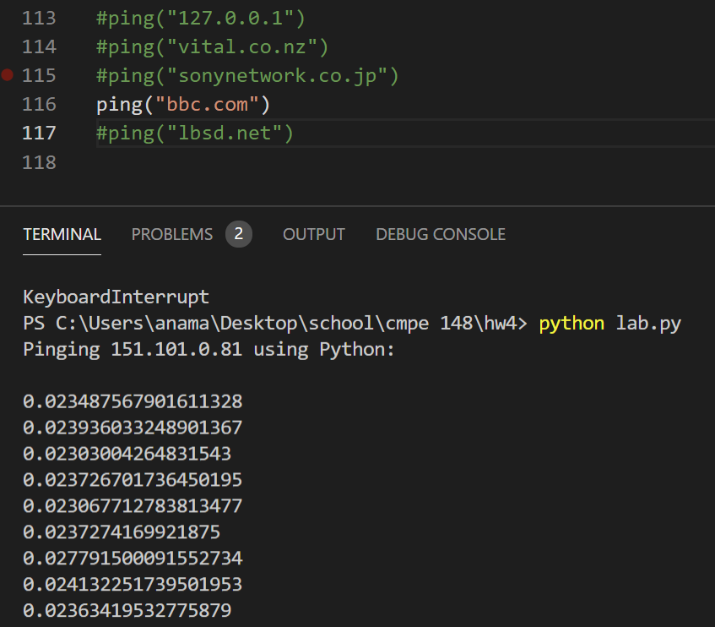

Pinger Output for lbsd.net

